Alvin Lucier’s “I am sitting in a room” as a piece constitutive of slow technology
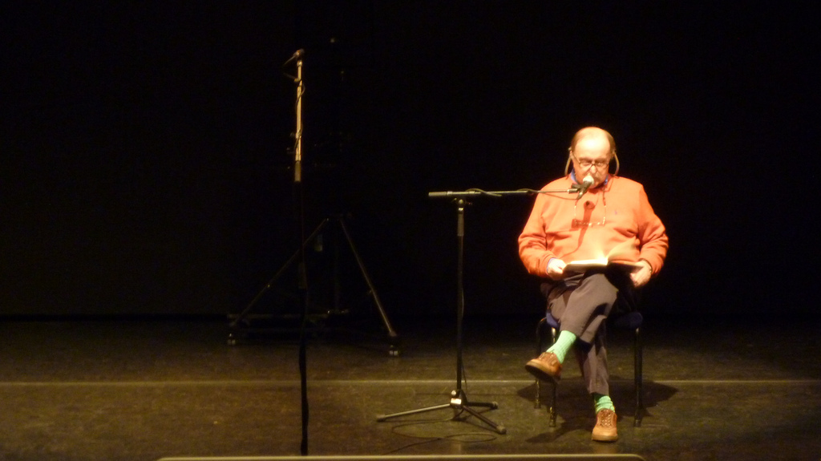
Picture source: Flikr
Alvin Lucier’s piece for voice on tape entitled “I am sitting in a room” illustrates our view of slow technology nicely. “I am sitting in a room” was composed in 1970 and was first performed at the Guggenheim Museum in New York City that same year. In the piece, we hear Alvin Lucier saying:
I am sitting in a room different from the one you are in now. I am recording the sound of my speaking voice and I am going to play it back into the room again and again until the resonant frequencies of the room reinforce themselves so that any semblance of my speech, with perhaps the exception of rhythm, is destroyed. What you will hear, then, are the natural resonant frequencies of the room articulated by speech. I regard this activity not so much as a demonstration of a physical fact, but more as a way to smooth out any irregularities my speech might have.
The text repeats 32 times, each repetition a recording of the previous iteration, played into the room. At the end of the 40 minute piece, all we hear are the harmonies of the resonant frequencies of the room.
A number of things interest us about this piece. First of all, it exposes its own workings. The piece is transparent about its inner workings through Lucier’s spoken explanation, and by exposing the resonant frequencies of the room. Second, it exposes the influence, or even destructive force of infrastructure (the room), something people are not usually aware of. What’s more, the listener can only fully understand and experience what the piece is about over the entire duration of the piece.

